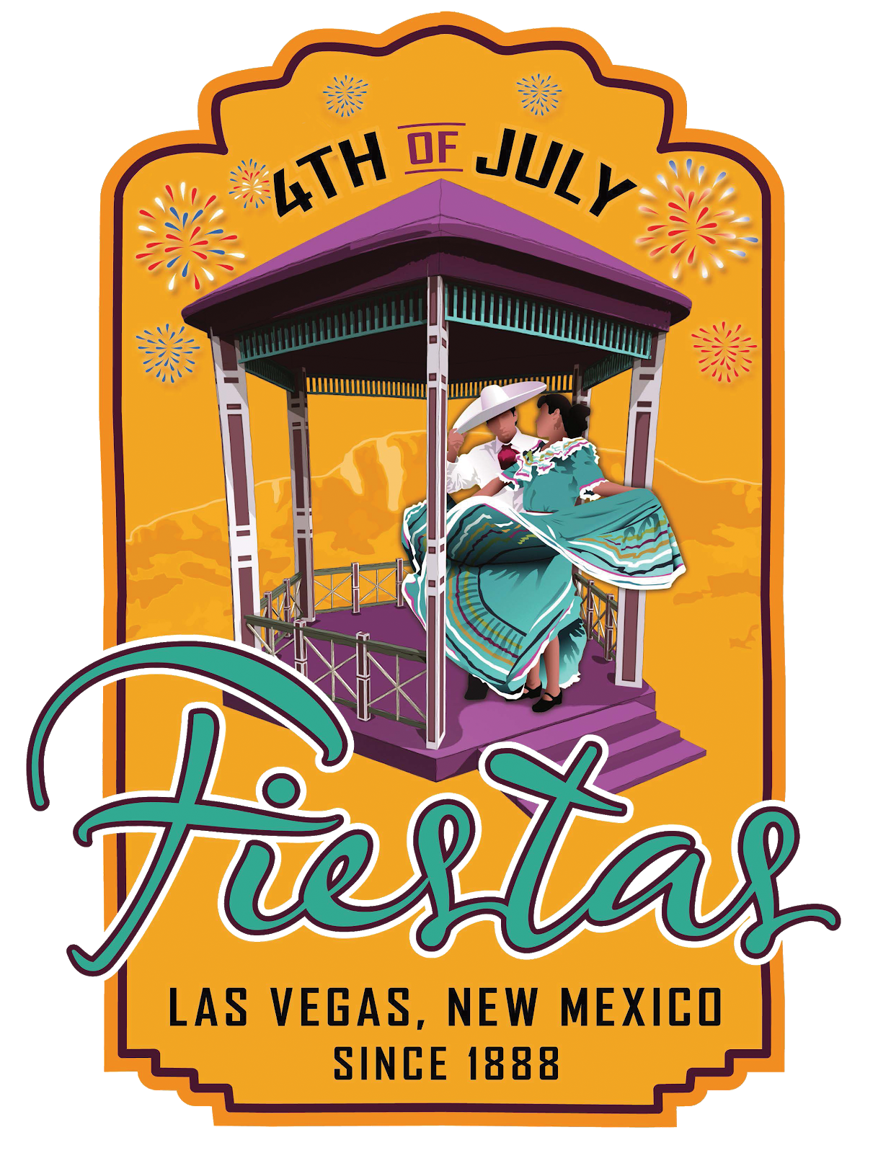PARADE APPLICATION FORM
4th of July Fiestas 2023
July 1, 2023 – July 4, 2023

Return to: City of Las Vegas ATTN: Fiesta Committee 1700 N. Grand Avenue
Las Vegas, NM 87701 505-454-1401

Application Due Date: Thursday, June 16, 2023 by 5:00 PM
Point of Contact: Charles Griego at (505) 454-1401 ext 1604

GENERAL INFORMATION

Entry Name:

Contact Person:

Contact Phone #: Secondary Contact Phone #:

Email Address:
Number of Participants:

Number of Vehicles:
Number of horses:

SCHEDULE  6:30 a.m. Line-up at Second Street off of Mills Ave. 6:30 a.m. - 7:30 a.m. Fire Department Inspections 9:00 a.m. Parade Promptly Starts | FREE TO ALL PARTICIPANTS
 | Please have Valid Driver’s License, Registration and Proof of Insurance

Parade Rules for Riders and Horses is incorporated into this application and made a part hereof. All horses must be placed located at the close of the parade. Owners are responsible for cleaning up feces during the parade.

The Fiestas Work Group and designees for the Fiestas Parade reserve the right to line-up and place floats in an order conducive to the theme of the parade, taking into account the positive promotion of the City of Las Vegas and in order to maximize visual and auditory appeal for spectators.

Participants are not to throw candy.

I understand and will abide by the rules set forth by the City of Las Vegas and the Fiestas Work Group. I hereby certify that the foregoing statements to be true and correct, and agree to defend, indemnify and hold harmless the City of Las Vegas, its City Council, officers, agents, employers and volunteers from and against any and all losses, claims, damages, liability such claim or suit arising or in any manner connected to the requested activity.

Parade Rules

- All riders MUST be registered to participate in the parade.

- All riders MUST display registration ID, as determined by the Fiestas Work Group.

- Riders 10 years old and under MUST be either ground lead or be tethered to an adult riders horse.

- Zero tolerance towards “Alcohol” will be exercised. Riders suspected of drinking or found to have alcohol in their possession will be removed from the parade. Possible seizure/impoundment of the horse and municipal citation will be issued.
- All riders will strictly control their horses. No reckless behavior will be tolerated.

- All riders will remain where assigned within the parade. Any riders found moving either up or down the parade line will be removed from the parade. Possible seizure/impoundment of the horse and municipal citation will be issued.
- No horses will be allowed in the plaza park area. Horses should be secured within their horse trailer and removed from the park area as soon as possible.
- All riders will follow all parade rules, as determined by the Fiesta Oversight Committee.

- No ATV’s will be allowed unless it is used to pull a trailer.

- All bicycles riders under the age of 18 must wear a helmet.

- DO NOT THROW CANDY!! Candy will not be allowed to be thrown from any vehicle in the parade.

- Generators must be adequately and safely anchored to float and inspected by the City of Las Vegas Fire Department prior to parade participation. Participants must adhere to all safety requests made by the City of Las Vegas Fire Department, Police Department and Fiesta Oversight Committee.
- All generators must be filled before the beginning of the parade. No filling of generators will be allowed during the parade.
- Children must be well secured and away from generator.

- Be on time.

- The Fiestas Work Group and designees for the Fiestas Parade reserve the right to line-up and place floats in an order conducive to the theme of the parade, taking into account the positive promotion of the City of Las Vegas and in order to maximize visual and audio appeal for spectators.

Name of Float:

Owner:

Address:

City of Las Vegas Float Inspection Checklist

A minimum five (5) pound Fire Extinguisher is required. The Las Vegas Fire Department (LVFD) will not lend out extinguishers. Please do not ask.

Extension cords and lights must be UL approved. Frayed or cracked extension cords will not be allowed.

Floats must be made of non-flammable, non-combustible material. No cardboard or paper stuffing.

If you carry a gas can for your float, it must be approved for gas containment and kept away from all lighting or any heat source including generators.

If you use more than one extension cord, you will need an electric power strip with a breaker or a GFI receptacle.

Children must be well secured and away from generator.

All generators must be filled before the beginning of the parade. No filling of generators will be allowed during the parade.

Suggested materials are: Styrofoam, 2 inch insulation panels, foam board, cellutex, chicken wire, as well as plywood.

Floats may be inspected three (3) hours prior to the parade. It is recommended that you call LVFD for an inspection (Phone 505-425-6321) in the days prior to the parade since onsite inspection may not allow for correction of deficiencies.

